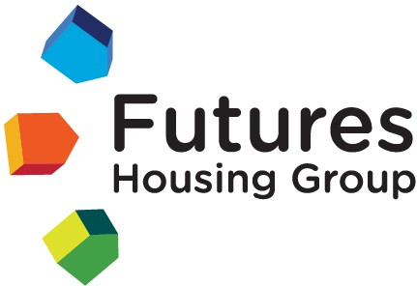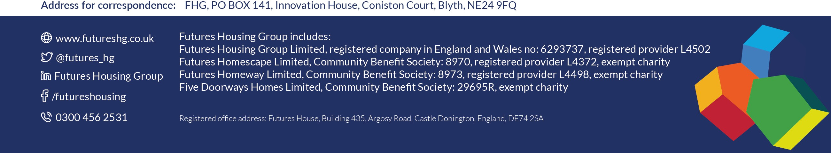

Futures Complaint Handling Code self-assessment – Response from Member Responsible for Complaints and Insight Committee Chair on behalf of the Board

At Futures Housing Group, customers and their needs are at the heart of everything we do. Listening to customers experiences and feedback enables us to shape services that best serve customers and the communities in which they live. Customer complaints are one of the many ways that we can listen and learn from customers.

We believe effective complaint handling is an essential part of our work, and it is managed by a dedicated in-house team. Where improvements are identified through an individual complaint or through several complaints with a similar root cause, they are recorded and tracked to make sure the improvements are delivered for customers.

Our Insight Committee is a sub-committee of the Board and includes customers, Board representatives and an independent member. The Committee makes sure that Futures Housing Group complies with the Housing Ombudsman’s *Complaint Handling Code* as part of a suite of performance management responsibilities. Insight Committee reviewed our self- assessment against the code on 13 March 2025. This included scrutinising evidence against all nine sections, namely:

1. Definition of a complaint
2. Exclusions
3. Accessibility and awareness
4. Complaint handling staff
5. The complaint handling process
6. Complaint stages
7. Putting things right
8. Self-assessment, reporting and compliance
9. Scrutiny and oversight: continuous learning and improvement.

Based on this review the Committee is satisfied we currently comply with the Code. We are using learning from complaints positively to support continuous improvement in our handling of complaints and service delivery.

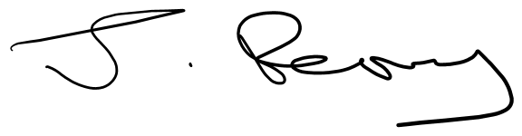

Jackie Perry

Board member / Chair of Insight Committee / Member Responsible for Complaints (MRC) 31 March 2025