Acuity Research and Practice logo.
 
This includes the tagline, 'Intelligence. Insight. Improvement' below the word 'Acuity', and three i's and a full stop in the shape of a triangle to the right. 

**Tenant Satisfaction Measures – Summary of Approach 2024/25**

**Futures Housing Group**

**Table of Contents**

Introduction 3

Summary of Achieved Sample & Sample Method 3

Timing of Survey 4

Collection Method(s) 4

Sample Method 4

Representativeness 5

Questionnaire 7

## **Introduction**

The Tenant Satisfaction Measures (TSM) Standard mandates that all registered providers develop and report TSMs in accordance with the guidelines set by the regulator. As part of this requirement, it is necessary for Futures Housing Group to inform its customers about its approach to conducting the TSM Perception survey and collecting data.

This document details Futures Housing Group’s methodology and outlines the criteria specified in the Regulator of Social Housing’s publication, Tenant Satisfaction Measures Return.

The Tenant Satisfaction Measures (TSM) Standard requires all registered providers to conduct tenant perception surveys and report performance annually as specified by the RSH. TSMs are intended to make landlords’ performance more visible to tenants so that tenants can hold their landlord to account. TSMs consist of 22 measures: 10 providing management information from data held by the landlord and 12 satisfaction measures gathered from tenant surveys. In addition to overall satisfaction with landlord services, the measures cover five key themes:

* Keeping properties in good repair
* Maintaining building safety
* Respectful and helpful engagement
* Responsible neighbourhood management
* Effective handling of complaints

Providers must publish a summary of the survey approach used to generate published tenant perception measures. This must be made clearly available alongside each set of tenant perception measures published by the provider.

## **Summary of Achieved Sample & Sample Method**

 Futures Housing Group works with Acuity Research & Practice Ltd, an accredited organisation that is dedicated to providing research services in the social housing sector. We use survey information to understand how our tenants feel about their homes and services and how we can improve. Acuity was commissioned for collecting, generating and validating reported perception measures.

In 2024/25, Futures Housing Group completed TSM surveys with a sample of residents. The sample size was chosen to ensure that the level of statistical accuracy set out by the Regulator of Social Housing was met. Futures Housing Group must ensure that they survey enough residents to meet a statistical accuracy (margin of error at 95% confidence interval) of +/- 4%.

During 2024/25, Futures Housing Group completed 1064 TSM surveys. Futures Housing Group have 9915 LCRA & LCHO properties which means that a statistical accuracy level of +/- 2.8% was achieved, which is a greater level of accuracy than required.

No tenant was removed from the sample frame.

No incentives were offered to tenants to complete the survey.

## **Timing of Survey**

Futures Housing Group carried out a total of 1064 surveys between 24/04/2024 and 15/01/2025.



## **Collection Method(s)**



The TSM Surveys were completed via telephone and online. The rationale for using a mixed methodology approach is:

* **Accessibility and Inclusivity**: Ensuring accessibility for all tenants, which aligns with our goal of reaching a broad and representative sample.
* **Engagement and Data Quality**: Indirect interaction by online, and direct interaction over the phone tends to enhance engagement, allowing participants to answer clarifying questions and leading to more accurate and detailed responses. This is particularly valuable for nuanced satisfaction metrics.
* **Response Rates**: Using a mixed method approach maximises the robustness of our data and ensuring the results truly reflect the tenant base. Continuing to include a telephone aspect also allows Futures Housing Group to be reactive to flags and alerts, which improves customer recovery.
* **Reliability and Consistency**: Maintaining consistency with previous years' methodologies allows for more reliable trend analysis. It also enables richer information to be gathered.
* **Independence**: Using Acuity, an independent market research agency, means that participants are free from influence from the rest of the organisation.

## **Sample Method**

The survey used a sample approach. Acuity contacted a random selection of current tenants from LCRA and LCHO tenancies to participate in the survey based on quotas set on tenure, age, and company. The survey was carefully scripted to ensure a professional and consistent process.

Survey responses are immediately shared with Futures Housing Group, who then manage a follow up and review process which includes both responding to feedback as necessary, and analysing the feedback, to understand how we can improve.

## **Representativeness**

Representative checks were carried out to ensure that the survey was representative of the tenant population as a whole. The characteristics by which representativeness was determined were:

Tenure, Age, and Company.

|  |  |  |
| --- | --- | --- |
| **LCRA/LCHO** | **Population** | **Sample** |
| LCRA | 95% | 91% |
| LCHO | 5% | 9% |

|  |  |  |
| --- | --- | --- |
| **Tenure** | **Population** | **Sample** |
| Intermediate Rent | 1% | 1% |
| Limehouse | 1% | 2% |
| Other | 0% | 0% |
| Shared Ownership | 5% | 9% |
| Social & Affordable | 92% | 88% |
| Supported | 1% | 1% |

|  |  |  |
| --- | --- | --- |
| **Age Group** | **Population** | **Sample** |
| 0 - 24 | 2% | 2% |
| 25 - 34 | 13% | 15% |
| 35 - 44 | 19% | 19% |
| 45 - 54 | 16% | 16% |
| 55 - 59 | 10% | 9% |
| 60 - 64 | 9% | 8% |
| 65 - 74 | 14% | 14% |
| 75 - 84 | 12% | 11% |
| 85 + | 5% | 4% |

|  |  |  |
| --- | --- | --- |
| **Company** | **Population** | **Sample** |
| FHL | 66% | 66% |
| FHW | 34% | 34% |

|  |  |  |
| --- | --- | --- |
| **No. of bedrooms** | **Population** | **Sample** |
| 0 | 0% | 0% |
| 1 | 22% | 25% |
| 2 | 38% | 39% |
| 3 | 38% | 33% |
| 4 | 2% | 3% |
| 5 | 0% | 0% |
| 6 | 0% | 0% |

|  |  |  |
| --- | --- | --- |
| **Length of Tenancy** | **Population** | **Sample** |
| A. < 1 year | 3% | 8% |
| B. 1 - 3 years | 21% | 27% |
| C. 4 - 5 years | 12% | 12% |
| D. 6 - 10 years | 23% | 22% |
| E. 11 - 20 years | 24% | 18% |
| F. Over 20 years | 18% | 13% |

|  |  |  |
| --- | --- | --- |
| **Property Type** | **Population** | **Sample** |
| Bedsit | 0% | 1% |
| Bedsit First Floor | 0% | 0% |
| Bungalow (Detached) | 0% | 1% |
| Bungalow (End) | 1% | 1% |
| Bungalow (Semi) | 17% | 17% |
| Bungalow (Mid) | 1% | 1% |
| First Floor Flat General | 3% | 5% |
| First Floor Sheltered Flat | 6% | 6% |
| Flat | 2% | 2% |
| Former Notts Comm Reema Prop | 1% | 1% |
| Ground Floor Flat General | 3% | 3% |
| Ground Floor Sheltered | 5% | 6% |
| House | 0% | 0% |
| House (Detached) | 1% | 1% |
| House (End Terrace) | 11% | 11% |
| House (Mid Terrace) | 6% | 6% |
| House (SemI) | 41% | 36% |
| Maisonette | 1% | 2% |
| Second Floor Flat General | 0% | 0% |
| Shared Bedspaces | 0% | 0% |
| Sheltered Bungalow | 0% | 0% |

|  |  |  |
| --- | --- | --- |
| **Gender** | **Population** | **Sample** |
| Female | 68% | 68% |
| Male | 32% | % |

## **Questionnaire & Introductory Text**

Here is the introductory text and question set used for Futures Housing Group TSM surveys.

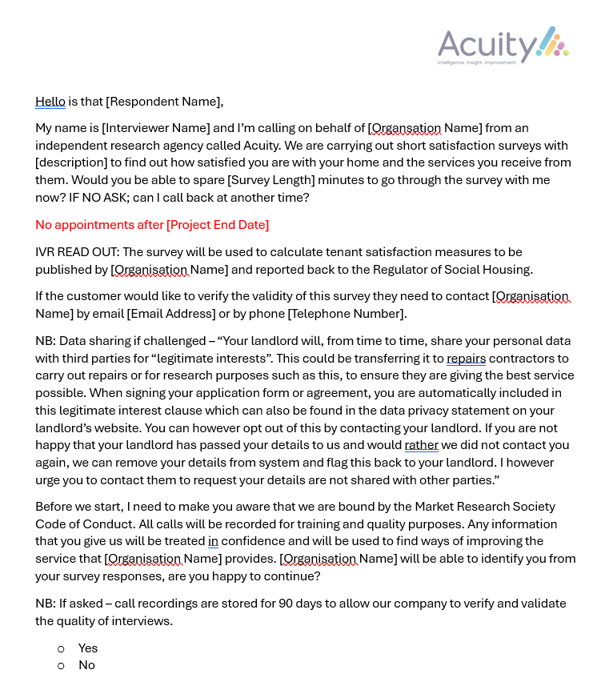

|  |  |  |
| --- | --- | --- |
| **Label** | **Question text** | **Rating scale** |
| Overall Satisfaction | Taking everything into account, how satisfied or dissatisfied are you with the service provided by Futures Housing Group? | Very satisfied, Fairly satisfied, Neither satisfied nor dissatisfied, Fairly dissatisfied, Very dissatisfied |
| Overall Satisfaction Comments | Why do you say that? | Open Ended |
| Well Maintained Home | How satisfied or dissatisfied are you that Futures Housing Group provides a home that is well maintained? | Very satisfied, Fairly satisfied, Neither satisfied nor dissatisfied, Fairly dissatisfied, Very dissatisfied |
| Safe Home | Thinking about the condition of the property or building you live in, how satisfied or dissatisfied are you that Futures Housing Group provides a home that is safe? | Very satisfied, Fairly satisfied, Neither satisfied nor dissatisfied, Fairly dissatisfied, Very dissatisfied, Not applicable / Don`t know |
| Communal Areas? | Do you live in a building with communal areas, either inside or outside, that Futures Housing Group is responsible for maintaining? | Yes, No, Don`t know |
| Communal Area Satisfaction | How satisfied or dissatisfied are you that Futures Housing Group keeps these communal areas clean and well-maintained? | Very satisfied, Fairly satisfied, Neither satisfied nor dissatisfied, Fairly dissatisfied, Very dissatisfied, Not applicable / Don't know |
| Repairs in Last 12 Months | Has Futures Housing Group carried out a repair to your home in the last 12 months? | Yes, No |
| Repairs Last 12 Months Satisfaction | How satisfied or dissatisfied are you with the overall repairs service from Futures Housing Group over the last 12 months? | Very satisfied, Fairly satisfied, Neither satisfied nor dissatisfied, Fairly dissatisfied, Very dissatisfied |
| Time Taken Repairs | How satisfied or dissatisfied are you with the time taken to complete your most recent repair after you reported it? | Very satisfied, Fairly satisfied, Neither satisfied nor dissatisfied, Fairly dissatisfied, Very dissatisfied |
| Overall Repairs | Generally, how satisfied or dissatisfied are you with the way Futures Housing Group deals with repairs and maintenance? | Very satisfied, Fairly satisfied, Neither satisfied nor dissatisfied, Fairly dissatisfied, Very dissatisfied |
| Listens and Acts | How satisfied or dissatisfied are you that Futures Housing Group listens to your views and acts upon them? | Very satisfied, Fairly satisfied, Neither satisfied nor dissatisfied, Fairly dissatisfied, Very dissatisfied, Not applicable / Don`t know |
| Keeps you Informed | How satisfied or dissatisfied are you that Futures Housing Group keeps you informed about things that matter to you? | Very satisfied, Fairly satisfied, Neither satisfied nor dissatisfied, Fairly dissatisfied, Very dissatisfied, Not applicable / Don`t know |
| Fairly and with Respect | To what extent do you agree or disagree with the following `Futures Housing Group treats me fairly and with respect`? | Strongly agree, Agree, Neither agree nor disagree, Disagree, Strongly disagree, Not applicable / Don`t know |
| Easy to Deal With | How satisfied or dissatisfied are you that Futures Housing Group are easy to deal with? | Very satisfied, Fairly satisfied, Neither satisfied nor dissatisfied, Fairly dissatisfied, Very dissatisfied, Not applicable / Don`t know |
| Opportunity to Make Views Known | How satisfied or dissatisfied are you that Futures Housing Group gives you the opportunity to make your views known? | Very satisfied, Fairly satisfied, Neither satisfied nor dissatisfied, Fairly dissatisfied, Very dissatisfied, Not applicable / Don`t know |
| Opportunity to participate in decision making process | Thinking about Futures Housing Group in general, how satisfied or dissatisfied are you with the opportunities given to you to participate in Futures Housing Group’s decision-making processes? | Very satisfied, Fairly satisfied, Neither satisfied nor dissatisfied, Fairly dissatisfied, Very dissatisfied, Not applicable / Don`t know |
| Decision Making Comments | How would you like to be involved in Futures Housing Group’s decision-making processes? | Open ended |
| Trust | How strongly would you agree or disagree with the following statement,  “I trust Futures Housing Group to do what they say they will do”? | Strongly agree, Agree, Neither agree nor disagree, Disagree, Strongly disagree, Not applicable / Don`t know |
| VFM Rent | How satisfied or dissatisfied are you that your rent provides value for money? | Very satisfied, Fairly satisfied, Neither satisfied nor dissatisfied, Fairly dissatisfied, Very dissatisfied, Not applicable / Don`t know |
| Contribution To Neighbourhood | How satisfied or dissatisfied are you that Futures Housing Group makes a positive contribution to your neighbourhood? | Very satisfied, Fairly satisfied, Neither satisfied nor dissatisfied, Fairly dissatisfied, Very dissatisfied, Not applicable / Don`t know |
| Approach to ASB | How satisfied or dissatisfied are you with Futures Housing Group’s approach to handling anti-social behaviour? | Very satisfied, Fairly satisfied, Neither satisfied nor dissatisfied, Fairly dissatisfied, Very dissatisfied, Not applicable / Don`t know |
| ASB in Last 12 Months | Have you experienced anti-social behaviour in your neighbourhood in the last 12 months? | Yes, No |
| Complaints in Last 12 Months | Have you made a complaint to Futures Housing Group in the last 12 months? | Yes, No |
| Complaints Handling | How satisfied or dissatisfied are you with Futures Housing Group’s approach to complaints handling? | Very satisfied, Fairly satisfied, Neither satisfied nor dissatisfied, Fairly dissatisfied, Very dissatisfied, Not applicable / Don`t know |
| Damp | Please can you tell me if your home has any issues with damp, mould, or condensation? | Yes, No, Don’t Know |
| Damp Comments | Please can you explain what the issues are? | Open Ended |
| Reported Damp | Have you reported the issue to Futures Housing Group? | Yes, No, Can’t Remember |
| Permission 1 | The results of this survey are confidential. However, would you be happy for us to give your responses to Futures Housing Group with your name attached so that they have better information to help them improve services? | Yes, No |
| Permission 2 | Would you be happy for Futures Housing Group to contact you to follow up on any of the comments or issues you have raised? | Yes, No |

**Report by Acuity Research & Practice**

01273 287114

acuity@arap.co.uk

01273 287114

01273 287114

01273 287114

01273 287114

acuity@arap.co.uk

acuity@arap.co.uk

01273 287114

www.arap.co.uk